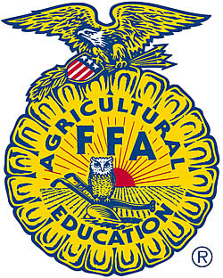

April 6, 2018 (change the date according to the current day)

Dear (Buyer),

On behalf of myself and the entire Allen FFA program I want to thank you for your generous support this year at the Collin County Junior Livestock Show. It takes generous support and donations from people like you to make these types of events a success. As an ag student, I work hard to take care of my (ANIMAL PROJECT) and spend many hours a week preparing for the livestock show. It is so rewarding to see hard work pay off.

At this year’s Collin County Junior Livestock Show my (ANIMAL PROJECT) placed (PLACING). This allowed me to participate in the premium auction and your contribution was used toward the purchase of my animal, as well as several other Allen FFA animal projects.

Thanks again for supporting Allen FFA.

Sincerely,

STUDENT (Type your name here) (Sign your name just under the “Sincerely”)

