Strategies for Feeding Modern Broilers

Animal : Poultry

Purina Animal Nutrition

Key practices for producing broiler chicks for show
- Observe and follow all show rules and regulations regarding the purchasing and showing of broilers.
- Purchase Pullorum-Typhoid clean broiler chicks. Use Honor® Show Chow® feed products.
- Follow recommended management practices during the entire brooding and grow-out period.
- Keep records on all expenses and receipts.
- Cull birds accurately and select the show pen properly.

House set-up and pre-brood for show broiler chicks
It is best to share your feed program/types with your Purina® dealer two weeks prior to your needs. This allows the dealer to plan the order and ensure fresh, quality, feed throughout the grow-out period.
- Allow two square feet per bird that you start plus allow square footage for feeders and watering equipment
- Supply one feeder for every 20 broilers (this is a minimal requirement)
- Supply one watering unit for every 15 broilers (this is a minimal requirement)
- Place at least 4 inches of litter (pine shavings) throughout the house
- Adequate house lighting is needed - 24 hour light is necessary
- 40 Watt light bulbs (incandescent / fluorescent) are recommended
- Place 1-250 watt red heat lamps per 25 broilers (this is a minimal requirement)
- Have house set-up complete and begin heating the house 3 days prior to receipt of the broilers
- Brood temperature (litter temperature) should be 90ºF at floor level, 12” from the center
- beam of the brooder lamp Water temperature should be 80ºF for the first 5 days. Bird performance will be negatively impacted if the broilers become too warm or cold
- Keep fresh air in the houses but avoid cold drafty air on the broilers
Time spent in the broiler house is a major key to the success of your project. The more the birds are stimulated, the better performance you gain at the show. Each time someone enters the house, shake the feeders, and slowly walk around the house (stirring the litter), and making the birds get up and eat/drink/exercise. The more time spent in the house, the better the birds perform.
It takes TIME, TIME, TIME!

Show broiler pre-brood dates
- 2 weeks prior: visit with your Purina® dealer about feeding plans
- 1 week prior: set-up and equip the broiler house with litter and all equipment; Test all equipment including lights, heat lamps, feeders, waterers, etc.
- 3 days prior: begin heating the broiler house - the key to a good start
- 1 day prior: check progress of pre-brood temperatures. Make final adjustments if needed.
- 1 hour prior to receiving birds, add feed to feeders. Prepare water (80ºF) and place in waterers.

Receiving show broilers
Receive birds and confirm band numbers at time of placement in the house. Call the Ag Teacher/CEA within 24 hours of placing the birds if there are discrepancies with band numbers and/or bird health issues.

What to feed show broilers

Feeding show broilers: Week 1
Feeding | Honor® Show Chow® Poultry Prestarter
Management | Maintain brood temperature at least 90ºF  Change water every 24 hours after placement of birds and every 24 hours after that.

Feeding show broilers: Week 2
Feeding | For every 20 lbs of Honor® Show Chow® feed blend the following:  - 10 lbs of Honor® Show Chow® Poultry Prestarter  - 10 lbs of Honor® Show Chow® Poultry Starter  - 8 oz High Octane® Power Fuel® Supplement  - 8 oz High Octane® Champion Drive™ Supplement
Management | Maintain house temperature at 80ºF  Keep fresh water available at all times.  10 days of age - spread wing bands open.  Weather permitting, allow fresh air ventilation. Stir the air with a fan. Avoid creating cool draft on the birds.

Feeding show broilers: Week 3
Feeding | For every 20 lbs of Honor® Show Chow® feed blend the following:  - 3 lbs of Honor® Show Chow® Poultry Prestarter  - 17 lbs of Honor® Show Chow® Poultry Starter  - 8 oz High Octane® Power Fuel® Supplement  - 8 oz High Octane® Champion Drive™ Supplement
Management | Maintain house temperature at 75ºF  Keep fresh water available at all times.  Weather permitting, allow fresh air into the house. If weather does not permit fresh air ventilation, stir air with a fan. Avoid creating cool draft on the birds.  Plan a day for the week 4 to cull birds. Ensure the availability of additional people to help.  Look at litter condition - Add 2-3 additional bags or clean entire house out and replace with new shavings maintaining a minimal 4” base throughout the house.

Feeding show broilers: Week 4
Feeding | For every 20 lbs of Honor® Show Chow® feed blend the following:  - 15 lbs of Honor® Show Chow® Poultry Starter  - 5 lbs of Honor® Show Chow® Poultry Grow-Fin  - 8 oz High Octane® Power Fuel® Supplement  - 8 oz High Octane® Champion Drive™ Supplement
Management | Maintain house temperature at 70ºF  Keep fresh water available at all times  Weather permitting, allow fresh air into the house. If weather does not permit fresh air ventilation, stir air with a fan. Avoid creating cool draft on the birds.  On or before 28 days of age, cull birds down to approximately 3 birds for every bird that will be entered in the show. Example: 1 pen of 3 broilers shown - Cull down to 9-12 broilers. The criteria used for culling is the same as for picking the show pen

Feeding show broilers: Week 5
Feeding | For every 20 lbs of Honor® Show Chow® feed blend the following:  - 8 lbs of Honor® Show Chow® Poultry Starter  - 12 lbs of Honor® Show Chow® Poultry Grow-Fin  - 8 oz High Octane® Power Fuel® Supplement  - 8 oz High Octane® Champion Drive™ Supplement
Management | Maintain house temperature at 68ºF  Keep fresh water available at all times  Weather permitting, allow fresh air into the house. If weather does not permit fresh air ventilation, stir air with a fan. Avoid creating cool draft on the birds.  Read show rules, regulations and guidelines to showing broilers

Feeding show broilers: Week 6 (continue through until show date)
Feeding | For every 20 lbs of Honor® Show Chow® feed blend the following:  - 20 lbs of Honor® Show Chow® Poultry Grow-Fin  - 8 oz High Octane® Power Fuel® Supplement  - 8 oz High Octane® Champion Drive™ Supplement
Management | Maintain house temperature at 68ºF  Keep fresh water available at all times  Weather permitting, allow fresh air into the house. If weather does not permit fresh air ventilation, stir air with a fan. Avoid creating cool draft on the birds.  Evaluate litter condition – clean-out entire house if it was not done at three weeks of age. Add 3-4 additional bags of litter if the house was cleaned out at 3 weeks of age (depending on litter condition).
At the beginning of the week - Begin to prepare for transport of birds to the show. Locate cardboard box and purchase fresh shavings (shavings from house not recommended unless they are exceptionally clean). Insure availability of additional people to assist in holding birds for pen selection. If it is a morning show, select birds the night before. If it is an afternoon/evening show, select birds the morning of the show in cool weather only. During hot weather, select birds after 9:00 p.m. prior to show.

Show broiler pen selection
Do not over handle the birds. Too much feeling, squeezing, and hanging upside down creates stress on the birds and causes birds to soften and possibly die. Remember, prior to pen selection look for defects that would result in disqualification. Remove those birds (if any) and select the top birds for a pen to show. Mark bird on the leg with magic/paint marker. Mark the first choice pen of birds all the same. Mark alternate birds with a different color or mark for quick identification. Avoid tie wraps, string or leg bands for identification purposes.

Criteria for broiler pen selection:
- Length of breast bone – Measure from the “V” in the breast to the end point of the breast (keel) bone. The longer the breast (keel) bone the better.
- Depth of body – The measurement from the front of the breast to the backbone should be considered. Deep bodied birds will exhibit more muscle mass.
- Width of the breast muscle – Using your hand, measure the width of the breast muscle. Wide breasted birds are desired.
- Tapering of the breast – measure the amount of taper (loss of muscling) as you evaluate the breast muscle toward the back of the breast (keel) bone. Minimal amount of taper is best.
SHOW TIME - GOOD LUCK!!​
Click here to download feeding strategy pdf.

Related Education Content

Article
Tips on Feeding Show Turkeys

Honor® Show Chow® Winners

Honor® Show Chow® Feed Top Performer Program

View All Show Education

Related Products

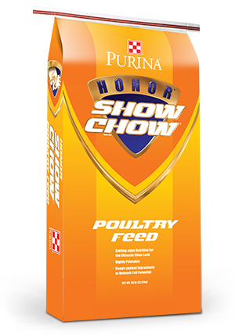
Purina® Honor® Show Chow® Poultry Starter

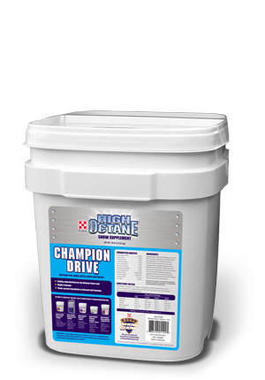
Purina® High Octane® Champion Drive Topdress (30lb)

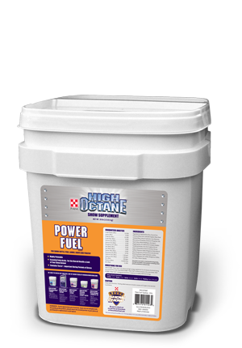
Purina® High Octane® Power Fuel®Topdress

